Geometric Proof Frameworks

Definition
# Source: AI Source: Provided by: [Data Path: Persons Table -> ID Column: 1, Name_En Column: Motasem Essam] -> From: [ChatGPT] on [7/25/2026]
Geometric Proof Frameworks are systematic mathematical approaches used to organize and establish geometric conclusions by applying particular types of geometric information, mathematical tools, and established relationships.
A proof framework determines what kind of mathematical evidence and relationships are primarily used to establish the conclusion.
$$\boxed{\text{Given Information}→\text{Geometric Framework}→\text{Logical Reasoning}→\text{Conclusion}}$$
For example, a proof may use triangle congruence as its framework, while using direct reasoning as its logical method and a two-column proof as its presentation format.

Main Types of Geometric Proof Frameworks
# Source: AI Source: Provided by: [Data Path: Persons Table -> ID Column: 1, Name_En Column: Motasem Essam] -> From: [ChatGPT] on [7/25/2026]
A practical classification is:
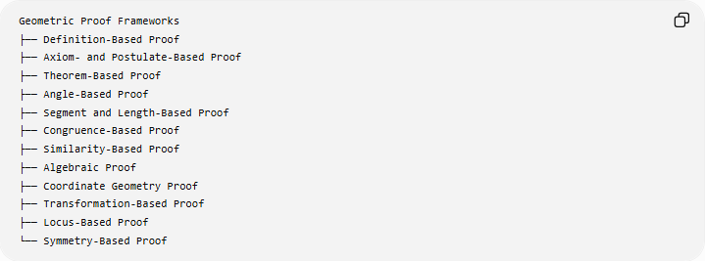
Geometric Proof Frameworks
├── Definition-Based Proof
├── Axiom- and Postulate-Based Proof
├── Theorem-Based Proof
├── Angle-Based Proof
├── Segment and Length-Based Proof
├── Congruence-Based Proof
├── Similarity-Based Proof
├── Algebraic Proof
├── Coordinate Geometry Proof
├── Transformation-Based Proof
├── Locus-Based Proof
└── Symmetry-Based Proof
Important: These are frameworks based on the mathematical tools used in a proof. They are not mutually exclusive, and terminology can vary between textbooks.

1. Definition-Based Proof

Definition
# Source: AI Source: Provided by: [Data Path: Persons Table -> ID Column: 1, Name_En Column: Motasem Essam] -> From: [ChatGPT] on [7/25/2026]
A Definition-Based Proof establishes a geometric conclusion primarily by applying the definitions of the geometric objects or relationships involved.
Definitions specify the exact properties that make a geometric object or relationship what it is.

Common Definitions
# Source: AI Source: Provided by: [Data Path: Persons Table -> ID Column: 1, Name_En Column: Motasem Essam] -> From: [ChatGPT] on [7/25/2026]
- midpoint,
- angle bisector,
- perpendicular lines,
- parallel lines,
- congruent segments,
- congruent angles,
- circle,
- polygon,
- isosceles triangle,
- rectangle,
- square.

Example: Midpoint
# Source: AI Source: Provided by: [Data Path: Persons Table -> ID Column: 1, Name_En Column: Motasem Essam] -> From: [ChatGPT] on [7/25/2026]
Given
$M$is the midpoint of $\overset{‾}{AB}$.
Prove
$$AM=MB$$
Proof
By the definition of a midpoint, a midpoint divides a segment into two congruent segments.
Therefore:
$$\boxed{AM=MB}$$
The definition itself supplies the essential justification.

Example: Angle Bisector
# Source: AI Source: Provided by: [Data Path: Persons Table -> ID Column: 1, Name_En Column: Motasem Essam] -> From: [ChatGPT] on [7/25/2026]
Given
Ray $BD$bisects $∠ABC$.
Prove
$$∠ABD=∠DBC$$
By the definition of an angle bisector:
$$\boxed{∠ABD=∠DBC}$$

2. Axiom- and Postulate-Based Proof

Definition
# Source: AI Source: Provided by: [Data Path: Persons Table -> ID Column: 1, Name_En Column: Motasem Essam] -> From: [ChatGPT] on [7/25/2026]
An Axiom- and Postulate-Based Proof uses fundamental statements accepted as true without proof as the primary foundation for a deduction.
Examples
- Through two distinct points, exactly one line can be drawn.
- All right angles are congruent.
- A segment can be extended indefinitely.
- A line can be drawn through two points.
These principles provide the foundation for more advanced geometric theorems.

Example
# Source: AI Source: Provided by: [Data Path: Persons Table -> ID Column: 1, Name_En Column: Motasem Essam] -> From: [ChatGPT] on [7/25/2026]
Given two distinct points:
$$A≠B$$
A basic Euclidean postulate establishes that exactly one line passes through both points.
Therefore:
$$\boxed{\text{There is exactly one line through }A\text{ and }B}$$
This fact can then be used in later geometric proofs.

3. Theorem-Based Proof

Definition
# Source: AI Source: Provided by: [Data Path: Persons Table -> ID Column: 1, Name_En Column: Motasem Essam] -> From: [ChatGPT] on [7/25/2026]
A Theorem-Based Proof uses one or more previously proven geometric theorems as the main tools for establishing a new conclusion.
A theorem that has already been proven can be used as a justified reason in another proof.

Example: Isosceles Triangle
# Source: AI Source: Provided by: [Data Path: Persons Table -> ID Column: 1, Name_En Column: Motasem Essam] -> From: [ChatGPT] on [7/25/2026]
Given
$$AB=AC$$
Prove
$$∠B=∠C$$
Since:
$$AB=AC$$
the triangle is isosceles.
By the Isosceles Triangle Theorem:
$$\boxed{∠B=∠C}$$
The theorem provides the main connection between the given side equality and the desired angle equality.

4. Angle-Based Proof

Definition
# Source: AI Source: Provided by: [Data Path: Persons Table -> ID Column: 1, Name_En Column: Motasem Essam] -> From: [ChatGPT] on [7/25/2026]
An Angle-Based Proof establishes a conclusion primarily through relationships among angles.
Common angle relationships include:
- vertical angles,
- linear pairs,
- complementary angles,
- supplementary angles,
- corresponding angles,
- alternate interior angles,
- alternate exterior angles,
- triangle angle sums,
- angle relationships in special triangles.

Example: Parallel Lines
# Source: AI Source: Provided by: [Data Path: Persons Table -> ID Column: 1, Name_En Column: Motasem Essam] -> From: [ChatGPT] on [7/25/2026]
Suppose:
$$l_{1}∥l_{2}$$
and a transversal intersects them.
If one corresponding angle measures:
$${70}^{∘}$$
then the corresponding angle is also:
$$\boxed{{70}^{∘}}$$
because corresponding angles formed by parallel lines are congruent.

Example: Triangle
# Source: AI Source: Provided by: [Data Path: Persons Table -> ID Column: 1, Name_En Column: Motasem Essam] -> From: [ChatGPT] on [7/25/2026]
If:
$$A={50}^{∘}$$
and:
$$B={60}^{∘}$$
then:
$$A+B+C={180}^{∘}$$
so:
$${50}^{∘}+{60}^{∘}+C={180}^{∘} \\ \boxed{C={70}^{∘}}$$
The main framework is angle-based reasoning.

5. Segment and Length-Based Proof

Definition
# Source: AI Source: Provided by: [Data Path: Persons Table -> ID Column: 1, Name_En Column: Motasem Essam] -> From: [ChatGPT] on [7/25/2026]
A Segment and Length-Based Proof establishes geometric conclusions primarily through relationships between segment lengths.
Common relationships include:
$$AB=CD \\ AB+BC=AC \\ AM=MB$$
and numerical length equations.

Example: Segment Addition
# Source: AI Source: Provided by: [Data Path: Persons Table -> ID Column: 1, Name_En Column: Motasem Essam] -> From: [ChatGPT] on [7/25/2026]
If $B$lies between $A$and $C$, then:
$$AB+BC=AC$$
Suppose:
$$AB=5$$
and:
$$BC=7$$
Then:
$$AC=5+7 \\ \boxed{AC=12}$$

6. Congruence-Based Proof

Definition
# Source: AI Source: Provided by: [Data Path: Persons Table -> ID Column: 1, Name_En Column: Motasem Essam] -> From: [ChatGPT] on [7/25/2026]
A Congruence-Based Proof establishes geometric conclusions by proving that two or more geometric figures have corresponding parts that are equal.
Triangle congruence is particularly important.
Standard Triangle Congruence Criteria
$$\boxed{SSS} \\ \boxed{SAS} \\ \boxed{ASA} \\ \boxed{AAS} \\ \boxed{RHS/HL}$$

Example
# Source: AI Source: Provided by: [Data Path: Persons Table -> ID Column: 1, Name_En Column: Motasem Essam] -> From: [ChatGPT] on [7/25/2026]
Suppose:
$$AB=DE \\ BC=EF$$
and:
$$∠B=∠E$$
The equal angle is included between the corresponding equal sides, so:
$$△ABC≅△DEF$$
by SAS.
Therefore, corresponding parts are congruent:
$$\boxed{AC=DF}$$
This final step uses CPCTC.

7. Similarity-Based Proof

Definition
# Source: AI Source: Provided by: [Data Path: Persons Table -> ID Column: 1, Name_En Column: Motasem Essam] -> From: [ChatGPT] on [7/25/2026]
A Similarity-Based Proof establishes relationships using figures that have the same shape but potentially different sizes.
For similar triangles:
$$△ABC∼△DEF$$
corresponding angles are congruent and corresponding sides are proportional.
$$\boxed{\frac{AB}{DE}=\frac{BC}{EF}=\frac{AC}{DF}}$$

Example
# Source: AI Source: Provided by: [Data Path: Persons Table -> ID Column: 1, Name_En Column: Motasem Essam] -> From: [ChatGPT] on [7/25/2026]
Suppose:
$$△ABC∼△DEF$$
and:
$$AB=6, DE=9$$
The scale factor from $ABC$to $DEF$is:
$$k=\frac{9}{6}=\frac{3}{2}$$
If:
$$BC=8$$
then:
$$\frac{8}{EF}=\frac{2}{3}$$
so:
$$EF=12$$
Therefore:
$$\boxed{EF=12}$$
Similarity provides the main framework.

8. Algebraic Proof

Definition
# Source: AI Source: Provided by: [Data Path: Persons Table -> ID Column: 1, Name_En Column: Motasem Essam] -> From: [ChatGPT] on [7/25/2026]
An Algebraic Proof uses algebraic equations, expressions, equality properties, and algebraic manipulation to establish a geometric conclusion.
Geometry supplies the relationships, while algebra provides the logical calculations.

Example
# Source: AI Source: Provided by: [Data Path: Persons Table -> ID Column: 1, Name_En Column: Motasem Essam] -> From: [ChatGPT] on [7/25/2026]
Suppose two segments are congruent:
$$AB=CD$$
and their lengths are:
$$AB=3x+5 \\ CD=2x+10$$
Therefore:
$$3x+5=2x+10$$
Subtract $2x$:
$$x+5=10$$
Subtract $5$:
$$\boxed{x=5}$$
The geometric equality produces the algebraic equation.

9. Coordinate Geometry Proof

Definition
# Source: AI Source: Provided by: [Data Path: Persons Table -> ID Column: 1, Name_En Column: Motasem Essam] -> From: [ChatGPT] on [7/25/2026]
A Coordinate Geometry Proof establishes geometric properties by assigning coordinates to points and using algebraic formulas.
Common tools include:
- distance formula,
- midpoint formula,
- slope,
- coordinate equations,
- algebraic equations.

Example: Proving a Segment Is Bisected
# Source: AI Source: Provided by: [Data Path: Persons Table -> ID Column: 1, Name_En Column: Motasem Essam] -> From: [ChatGPT] on [7/25/2026]
Let:
$$A\left(2 , 4\right)$$
and:
$$B\left(8 , 10\right)$$
The midpoint is:
$$M=\left(\frac{2+8}{2} , \frac{4+10}{2}\right) \\ M=\left(5 , 7\right)$$
Therefore, $M$is the midpoint of $\overset{‾}{AB}$.

Example: Proving Lines Are Parallel
# Source: AI Source: Provided by: [Data Path: Persons Table -> ID Column: 1, Name_En Column: Motasem Essam] -> From: [ChatGPT] on [7/25/2026]
For two nonvertical lines:
$$m_{1}=m_{2}$$
implies that they have the same direction.
Therefore:
$$\boxed{l_{1}∥l_{2}}$$
For perpendicular lines:
$$\boxed{m_{1}m_{2}=-1}$$
provided both slopes are defined.

10. Transformation-Based Proof

Definition
# Source: AI Source: Provided by: [Data Path: Persons Table -> ID Column: 1, Name_En Column: Motasem Essam] -> From: [ChatGPT] on [7/25/2026]
A Transformation-Based Proof establishes geometric relationships by applying transformations and using the properties that the transformations preserve.
Important transformations include:
- translation,
- rotation,
- reflection,
- glide reflection,
- dilation.

Isometry
# Source: AI Source: Provided by: [Data Path: Persons Table -> ID Column: 1, Name_En Column: Motasem Essam] -> From: [ChatGPT] on [7/25/2026]
An isometry preserves distances:
$$\boxed{d\left(T , \left(P\right)T\left(Q\right)\right)=d\left(P , Q\right)}$$
Therefore, isometries preserve:
- lengths,
- angle measures,
- congruence,
- shape and size.

Example: Reflection
# Source: AI Source: Provided by: [Data Path: Persons Table -> ID Column: 1, Name_En Column: Motasem Essam] -> From: [ChatGPT] on [7/25/2026]
Reflect a triangle across a line.
The image triangle has the same corresponding side lengths and angle measures.
Therefore:
$$\boxed{△ABC≅△A^{'}B^{'}C^{'}}$$
The reflection provides a transformation-based route to congruence.

Similarity Transformation
# Source: AI Source: Provided by: [Data Path: Persons Table -> ID Column: 1, Name_En Column: Motasem Essam] -> From: [ChatGPT] on [7/25/2026]
A dilation changes lengths by a common scale factor:
$$\boxed{d\left(T , \left(P\right)T\left(Q\right)\right)=k d\left(P , Q\right)}$$
while preserving angle measures.
Therefore, dilation can be used to establish similarity.

11. Locus-Based Proof

Definition
# Source: AI Source: Provided by: [Data Path: Persons Table -> ID Column: 1, Name_En Column: Motasem Essam] -> From: [ChatGPT] on [7/25/2026]
A Locus-Based Proof establishes a conclusion by using the set of all points satisfying a specified geometric condition.
A locus connects:
$$\boxed{\text{Geometric Condition}↔\text{Geometric Location}}$$

Example: Perpendicular Bisector
# Source: AI Source: Provided by: [Data Path: Persons Table -> ID Column: 1, Name_En Column: Motasem Essam] -> From: [ChatGPT] on [7/25/2026]
Consider all points $P$satisfying:
$$PA=PB$$
The locus of such points is the perpendicular bisector of $\overset{‾}{AB}$.
Therefore:
$$\boxed{PA=PB ⟺ P\text{ lies on the perpendicular bisector of }AB}$$
This is a classic locus relationship.

Another Example: Circle
# Source: AI Source: Provided by: [Data Path: Persons Table -> ID Column: 1, Name_En Column: Motasem Essam] -> From: [ChatGPT] on [7/25/2026]
The locus of all points at a fixed distance $r$from a center $O$is a circle.
$$OP=r$$
Therefore:
$$\boxed{\left\{P:OP=r\right\}=\text{circle centered at }O\text{ with radius }r}$$

12. Symmetry-Based Proof

Definition
# Source: AI Source: Provided by: [Data Path: Persons Table -> ID Column: 1, Name_En Column: Motasem Essam] -> From: [ChatGPT] on [7/25/2026]
A Symmetry-Based Proof uses a symmetry transformation to establish that geometric properties are preserved or that corresponding parts have equal relationships.
Common symmetry types include:
- reflection symmetry,
- rotational symmetry,
- central/point symmetry.

Example: Isosceles Triangle
# Source: AI Source: Provided by: [Data Path: Persons Table -> ID Column: 1, Name_En Column: Motasem Essam] -> From: [ChatGPT] on [7/25/2026]
An isosceles triangle has an axis of reflection symmetry passing through the vertex between the equal sides and the midpoint of the base.
Reflection across this axis maps one half of the triangle onto the other.
Therefore, corresponding parts have equal measures.
This supports:
$$\boxed{∠B=∠C}$$
and the base is bisected by the symmetry axis.

Frameworks Can Be Combined
# Source: AI Source: Provided by: [Data Path: Persons Table -> ID Column: 1, Name_En Column: Motasem Essam] -> From: [ChatGPT] on [7/25/2026]
A geometric proof does not have to use only one framework.
For example:

Triangle Congruence Proof
# Source: AI Source: Provided by: [Data Path: Persons Table -> ID Column: 1, Name_En Column: Motasem Essam] -> From: [ChatGPT] on [7/25/2026]
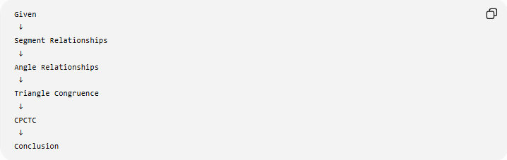
Given
↓
Segment Relationships
↓
Angle Relationships
↓
Triangle Congruence
↓
CPCTC
↓
Conclusion
This proof can simultaneously be:
- segment-based,
- angle-based,
- congruence-based,
- theorem-based,
- and direct.

Example of a Combined Proof
# Source: AI Source: Provided by: [Data Path: Persons Table -> ID Column: 1, Name_En Column: Motasem Essam] -> From: [ChatGPT] on [7/25/2026]
Suppose:
$$AB=AC$$
and $AD$bisects $∠A$.
Prove:
$$BD=DC$$
Reasoning
Because $AD$bisects $∠A$:
$$∠BAD=∠DAC$$
Given:
$$AB=AC$$
Also:
$$AD=AD$$
by the reflexive property.
Therefore:
$$△ABD≅△ACD$$
by SAS.
Using CPCTC:
$$\boxed{BD=DC}$$
This single proof uses several frameworks:
- Definition-Based — angle bisector;
- Angle-Based — equal angles;
- Segment-Based — equal sides;
- Congruence-Based — SAS;
- Theorem-Based — CPCTC;
- Direct Deductive Reasoning — the overall logical method.

Framework vs. Logical Method vs. Proof Format
# Source: AI Source: Provided by: [Data Path: Persons Table -> ID Column: 1, Name_En Column: Motasem Essam] -> From: [ChatGPT] on [7/25/2026]
This distinction is important.

1. Logical Method
# Source: AI Source: Provided by: [Data Path: Persons Table -> ID Column: 1, Name_En Column: Motasem Essam] -> From: [ChatGPT] on [7/25/2026]
Describes how the conclusion is logically established.
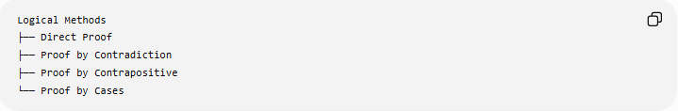
Logical Methods
├── Direct Proof
├── Proof by Contradiction
├── Proof by Contrapositive
└── Proof by Cases

2. Geometric Framework
# Source: AI Source: Provided by: [Data Path: Persons Table -> ID Column: 1, Name_En Column: Motasem Essam] -> From: [ChatGPT] on [7/25/2026]
Describes what mathematical tools are primarily used.
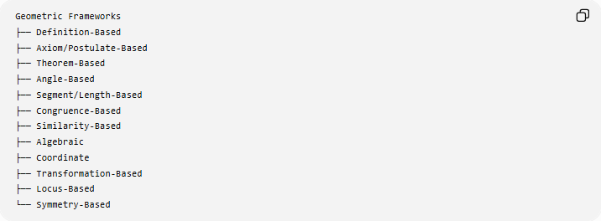
Geometric Frameworks
├── Definition-Based
├── Axiom/Postulate-Based
├── Theorem-Based
├── Angle-Based
├── Segment/Length-Based
├── Congruence-Based
├── Similarity-Based
├── Algebraic
├── Coordinate
├── Transformation-Based
├── Locus-Based
└── Symmetry-Based

3. Proof Presentation Format
# Source: AI Source: Provided by: [Data Path: Persons Table -> ID Column: 1, Name_En Column: Motasem Essam] -> From: [ChatGPT] on [7/25/2026]
Describes how the proof is written or displayed.
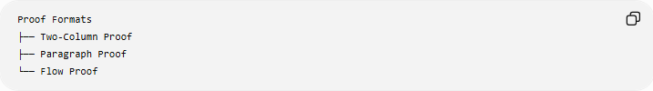
Proof Formats
├── Two-Column Proof
├── Paragraph Proof
└── Flow Proof
Therefore:
$$\boxed{\text{Logical Method}≠\text{Geometric Framework}≠\text{Proof Format}}$$

Comparison of Geometric Proof Frameworks
# Source: AI Source: Provided by: [Data Path: Persons Table -> ID Column: 1, Name_En Column: Motasem Essam] -> From: [ChatGPT] on [7/25/2026]
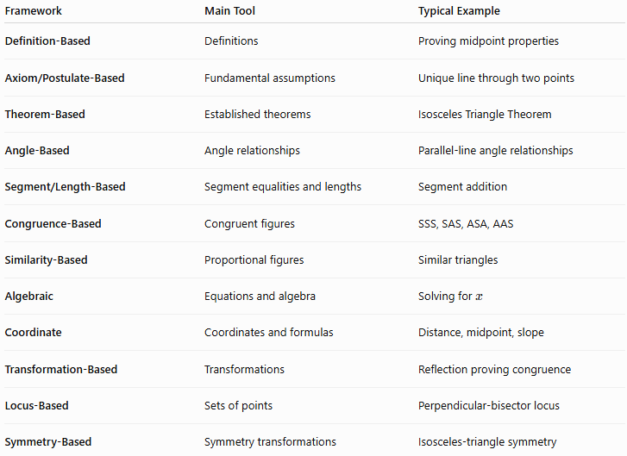
Framework | Main Tool | Typical Example
Definition-Based | Definitions | Proving midpoint properties
Axiom/Postulate-Based | Fundamental assumptions | Unique line through two points
Theorem-Based | Established theorems | Isosceles Triangle Theorem
Angle-Based | Angle relationships | Parallel-line angle relationships
Segment/Length-Based | Segment equalities and lengths | Segment addition
Congruence-Based | Congruent figures | SSS, SAS, ASA, AAS
Similarity-Based | Proportional figures | Similar triangles
Algebraic | Equations and algebra | Solving for $x$
Coordinate | Coordinates and formulas | Distance, midpoint, slope
Transformation-Based | Transformations | Reflection proving congruence
Locus-Based | Sets of points | Perpendicular-bisector locus
Symmetry-Based | Symmetry transformations | Isosceles-triangle symmetry

Classification
# Source: AI Source: Provided by: [Data Path: Persons Table -> ID Column: 1, Name_En Column: Motasem Essam] -> From: [ChatGPT] on [7/25/2026]
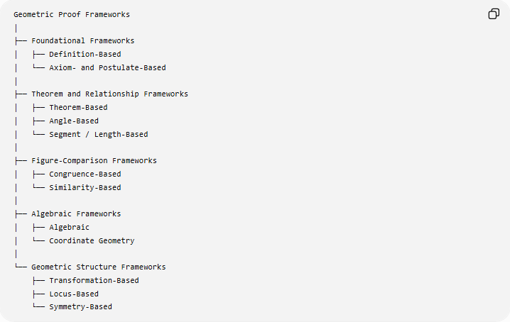
Geometric Proof Frameworks
│
├── Foundational Frameworks
│ ├── Definition-Based
│ └── Axiom- and Postulate-Based
│
├── Theorem and Relationship Frameworks
│ ├── Theorem-Based
│ ├── Angle-Based
│ └── Segment / Length-Based
│
├── Figure-Comparison Frameworks
│ ├── Congruence-Based
│ └── Similarity-Based
│
├── Algebraic Frameworks
│ ├── Algebraic
│ └── Coordinate Geometry
│
└── Geometric Structure Frameworks
├── Transformation-Based
├── Locus-Based
└── Symmetry-Based
This is a practical classification, and categories can overlap.

Key Points
# Source: AI Source: Provided by: [Data Path: Persons Table -> ID Column: 1, Name_En Column: Motasem Essam] -> From: [ChatGPT] on [7/25/2026]
- A geometric proof framework identifies the main mathematical tools used to establish a conclusion.
- Definitions can directly establish basic properties.
- Axioms and postulates provide foundational assumptions.
- Theorems provide previously proven relationships.
- Angle-based frameworks focus on angle relationships.
- Segment-based frameworks focus on lengths and segment relationships.
- Congruence establishes equal size and shape.
- Similarity establishes equal shape with proportional size.
- Algebraic and coordinate frameworks translate geometric relationships into mathematical equations.
- Transformation frameworks use preserved properties of geometric transformations.
- Locus frameworks connect geometric conditions with sets of points.
- Symmetry frameworks use invariant relationships under symmetry transformations.
- Multiple frameworks can be used within a single proof.
- Frameworks are different from logical proof methods and proof presentation formats.

Conclusion
# Source: AI Source: Provided by: [Data Path: Persons Table -> ID Column: 1, Name_En Column: Motasem Essam] -> From: [ChatGPT] on [7/25/2026]
Geometric Proof Frameworks provide different mathematical routes for establishing geometric conclusions. They determine whether the proof primarily relies on definitions, postulates, theorems, angles, lengths, congruence, similarity, algebra, coordinates, transformations, loci, or symmetry.
The overall relationship can be represented as:
$$\boxed{\text{Given}→\text{Choose Geometric Framework}→\text{Apply Logical Reasoning}→\text{Conclusion}}$$
A single proof may combine several frameworks. For example, a proof can be direct, congruence-based, angle-based, and theorem-based, while being presented as a two-column proof.

